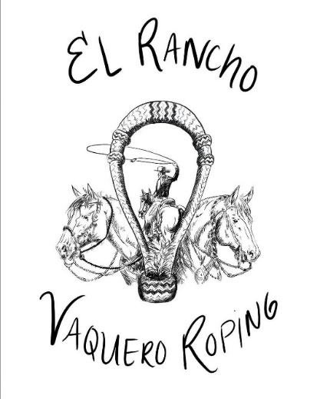
El Rancho Vaquero Roping
January 13, 2023~ Diamond Bar Arena, Ceres, CA
Friday Evening Branding Entry Form
Name:__________________________________ Phone: ____________________
Address:___________________________________________________________
Email:____________________________
$300 team
4-man teams; Timed Only Event
Must be entered in the Main Event to enter evening branding event
Full Payment must be received before entry is complete
Team Members:
Name:_______________________________ Phone:___________________
Name:_______________________________ Phone:___________________
Name:_______________________________ Phone:___________________
- Payment by check; Mail entry forms and checks payable to Stephanie Roundy, 6592 Jackson Valley Rd, Ione, CA 95640
- Email: elranchovaquero@elranchovaqueroroping.com
- You can enter on multiple teams as long as one team member is different on each team
- No refunds

